CPEG 298 ECE Design Challenges April 12, 2019

CPEG 298 Final Project Report

Team Members:   
Alexander Oliverio  
Shane Cincotta



CPEG 298 Final Project Report

# Abstract

The purpose of this project was to design a custom Arduino shield PCB to create a musical instrument. In our project, we used an FSR to control the pitch of our notes.

# Equipment:

* NI Multisim
* NI Ultiboard
* Diligent Explorer Breadboard
* Arduino UNO x1
* 0.1 μF Capacitor x2
* 10 μF Capacitor x1
* 2500 μF Capacitor x1
* 1 μF Capacitor x1
* 1 kΩ Resistor x1
* 1.1 kΩ Resistor x1
* 10 Ω Resistor x1
* 10 kΩ variable resistor x1
* 8 Ω speaker x1
* LM386 Op Amp x1
* FSR x1

# Procedure and Results:

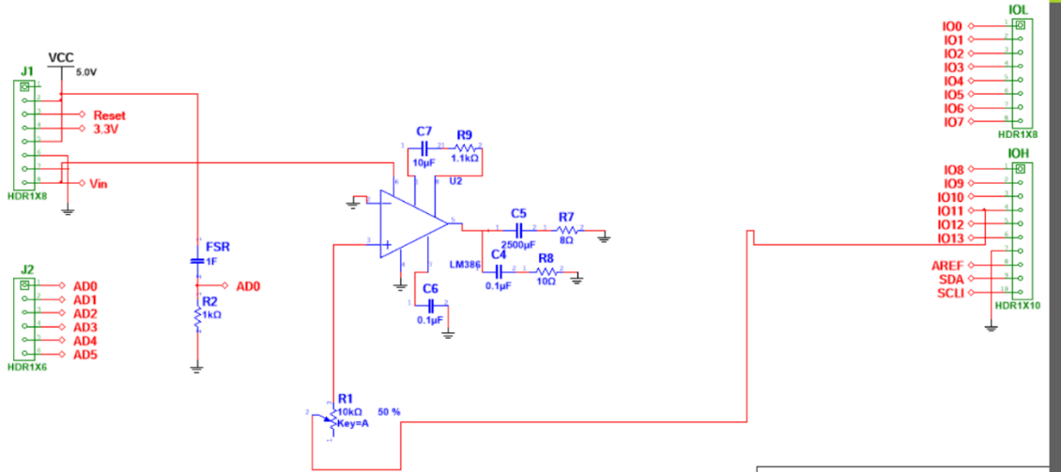 To Begin, the LM386 was chosen as our op amp. It was powered from the UNO board supply voltage of 5V (Pin 8 on the UNO). We designed it such that the maximum voltage gain was 40V/V. The voltage gain is controllable with a 10k variable resistor (R1) connected between the supply and the non-inverting terminal of the LM386. This essentially acted as the volume control. We used a 1.1kΩ resistor (R9) in series with a 10 μF capacitor (C7) for our negative feedback. Our load was the 8 Ω speaker (R7) which is in series with a 2500 μF capacitor, both of which are in parallel with a 0.1 μF capacitor (C4) in series with a 10Ω resistor (R8). Also, pin 7 was connected to a 0.1 μF capacitor (C6). Finally, our FSR was connected to VCC and in series with a 1 kΩ resistor (R2) as to limit the voltage across it.

Fig 1. Schematic of circuit built in Multisim

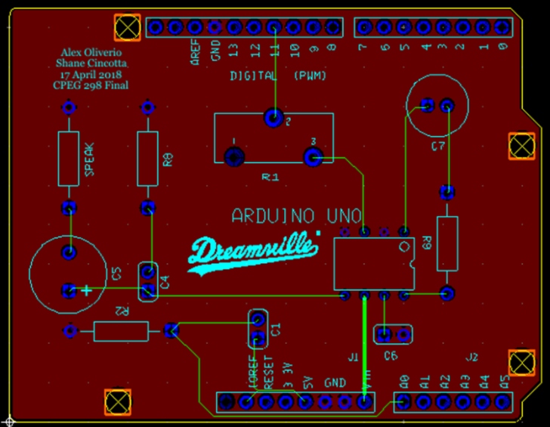 Next, we transferred our circuit from Multisim to NI Ultiboard. We were able to keep all traces on the top layer of the board.

Fig 2. Design transferred to Ultiboard with all traces

Finally, we began writing our code for the Arduino, which controls the PWM.

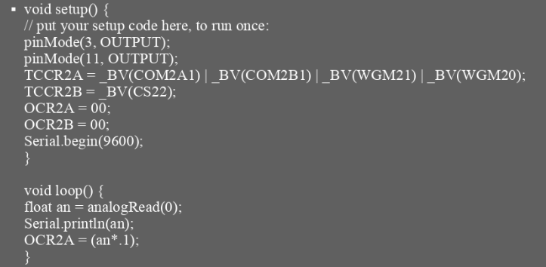

Fig 3. Code for Arduino which controls the fast PWM.

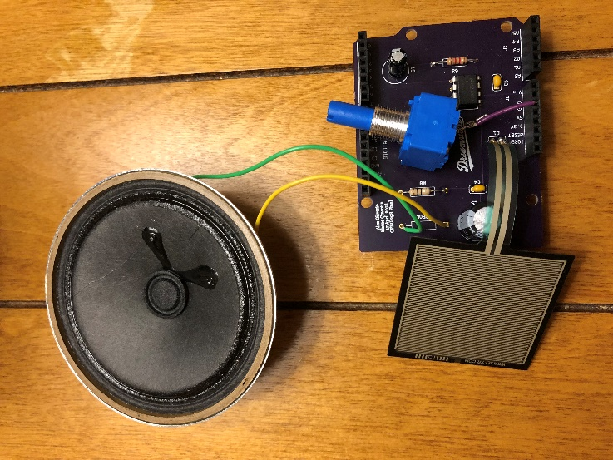Here is the end result with the FSR and speaker attached

Fig 4. Finished board with FSR and speaker attached.

# Conclusions and Questions:

Overall, our project was very efficient by the fact that minimal code and components were utilized while still fulfilling the end goal, which was to generate and control different tones with an Arduino UNO.

Although minimal components were used, we still encountered problems. The biggest problem we encountered was forgetting to attach VCC to the op amp. We didn’t realize we forgot until our board was already fabricated, thus we had to solder it on ourselves (the purple wire).